Safe4Summer: Water Safety Primary School Lesson Plan for Delivery

Programme of Study for PSHE Education: Keeping Safe section
KS1 | H33. about the people whose job it is to help keep us safe  H35. about what to do if there is an accident and someone is hurt  H36. how to get help in an emergency (how to dial 999 and what to say)
KS2 | H41. strategies for keeping safe in the local environment or unfamiliar places (rail, water, road) and firework safety; safe use of digital devices when out and about  H44. how to respond and react in an emergency situation; how to identify situations that may require the emergency services; know how to contact them and what to say

Slide/Video Information | Presenter notes – what to discuss | Source
 | Have the video up on the screen, paused and ready to play. Before you start the delivery make sure the audience can see the video. Provide a brief introduction of yourself, role and the Safe4Summer campaign.  Introduction could be as follows – Today we are going to show you a video with some safety tips by Lee Howells a Crew Manager at Bury Fire Station for Greater Manchester Fire and Rescue Service to help you keep safe in and around water.  Lee Howells will talk about:  - The dangers and consequences of swimming in open water  - What to do if you see someone in difficulty  - And how to stay safe around open water  Please watch and listen carefully as we will be asking you some questions later.  Press play on video. | Video
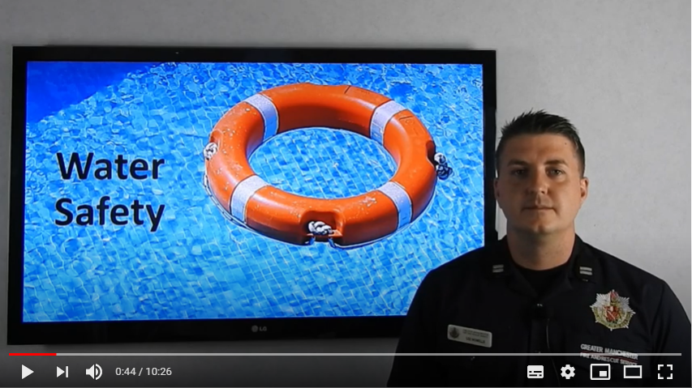  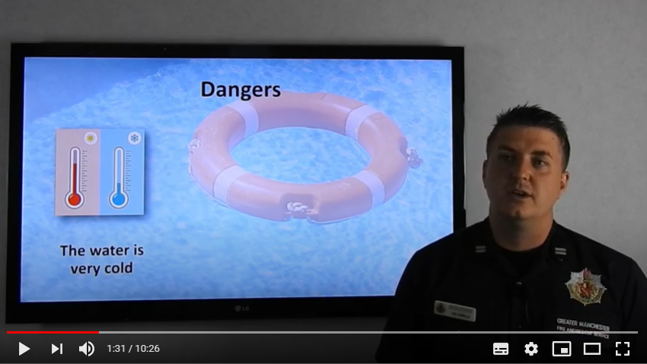 | PAUSE VIDEO…  Presenter is to pause the video at the time 0:44 after Lee finishes the sentence “each year we attend a number of incidents where people have got themselves into difficultly when entering open water”.  Q: Presenter to ask the audience if they can think of why swimming in open water can be dangerous?  Provide praise for correct answers.  Presenter to say: now let’s find out the answers from Lee.  Press play on the video.  PAUSE VIDEO…  Presenter is to pause the video at the time 1:31 after Lee finishes the sentence “go into something called cold water shock”  Q: Presenter to ask the audience, what they think cold water shock is and what would happen to your body in cold water?  Praise correct answers.  Presenter to say: now let’s go back to Lee to find out the answer as well as other dangers.  Press play on the video. | Video  Question and Answer
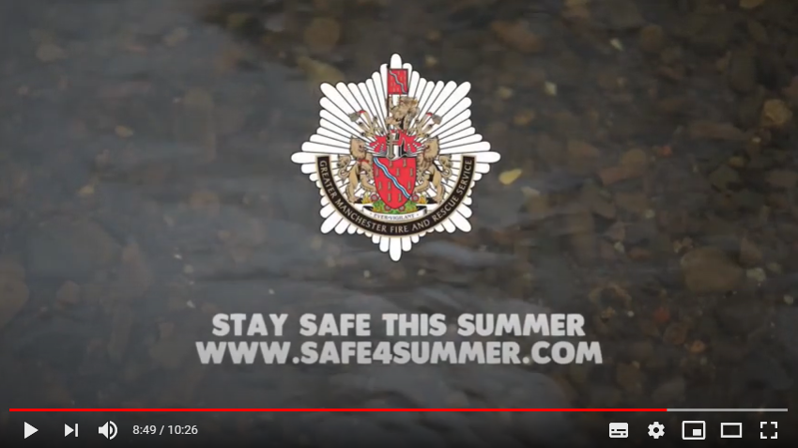 | PAUSE VIDEO…  Pause the video at the time 8:49, when you see the GMFRS logo appear.  Q: Presenter to ask the audience if they can remember the advice or key messages Firefighter Simon Dowling gave in the video?  Praise correct answers.  Answers: Stay calm, ring 999, say where you are, give landmarks, what has happened, get something to hold onto or something you can throw to the person in trouble, don’t/never go in.  Presenter to empathise the last point that even the strongest swimmers struggle in cold water and CM Howells is now going to tell you about a time this sadly happened.  Press play on video. | Video  Question and Answer
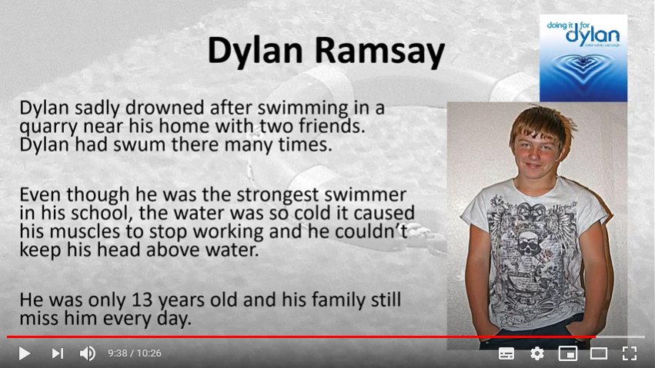 | PAUSE VIDEO…  Pause the video at the time 9:38 when Lee finishes the sentence “they would miss you everyday”  Presenter to empathise the key message: NEVER go in open water, as we want you all to stay safe this summer and to return home safely to your loved ones.  You can ask the whole class to repeat the key message: NEVER go in open water.  Press play on video. | Video
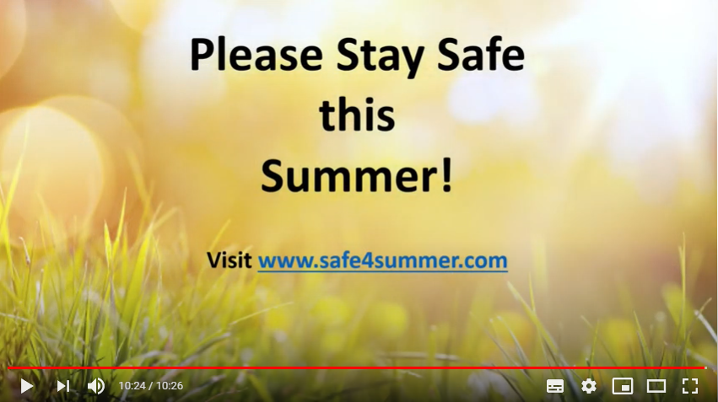 | PAUSE VIDEO…  Pause the video to finish at the time 10.24 when Lee finishes the sentence “loads of safety advice and games”, so that the audience can see the safe4summer website link.  Conduct facilitated question and answer session with the audience to check knowledge and understanding.  Ask one question at a time and praise correct answers.  The questions and key messages are detailed below:  Question 1 – Why is it dangerous to enter / swim in open water?  - The water is a lot colder than you think – The temperature of the water is very cold and it can cause your body to go into shock. This can prevent you from getting out of the water.  - The water can be deeper than you think – The water may seem shallow at first but then there can be sudden changes in depths. This could cause you to get into difficulty.  - The water can contain currents – Lakes, rivers, canals and reservoirs contain underwater currents or fast flowing water. This can affect even the strongest swimmers from getting out of the water.  Remember – Never enter the water for pets. As the Firefighter said in the video, dogs are not affected by the cold temperatures of the water like we are and they usually get out by themselves.  Question 2 – Can you think of any scary or dangerous things that can be found in the water?  - You don’t know what is in the water – There could be dangers beneath the water such as sharp objects, cables, shopping trolleys etc. Objects like these could cause injuries or obstructions preventing you from getting out of the water.  - The water can be contaminated with diseases– The water may look clean but it is not, which can make you very ill.  Question 3 – What should you do if you see someone in difficulty?  - Never enter the water – If you see someone in difficulty in the water, use your mobile phone (if you have one) or go to the nearest telephone, dial 999 and ask for the Fire and Rescue Service at inland water sites and the Coastguard at the beach.  - Know your location – It’s really important to know where you are. Look for any landmarks such as signs or shops that you could describe to the operator, and explain as clearly as possible where you are and what happened.  Remember – Never ever lean out over the water or enter the water to try and help - you are likely to get into difficulty yourself.  Question 4 – Where do you think is the safest place you can go swimming with your friends or family?  - The local swimming pool – It’s a safe environment where you can have fun with your family and friends. Unlike open water, there is also a lifeguard(s) on duty who can help should you or someone get into difficulty.  Remember – Never go in open water. | Video  Question and Answer
 | Final message – Please enjoy yourself with your friends and family but remember never put yourselves in situations that may be dangerous to yourself or others.  Think about the consequences of what could happen and how you and others may be affected.  Ask if there are any final questions.  Direct the audience to the Safe4Summer website (www.safe4summer.com) and where they can find the games and further advice.  Thank the audience for taking part in the session. | Video  Website

Please visit our Bury Safety Centre training site, which opens from the 28th June 2021 subject to Government guidelines. To find out more and to book a visit when we are back open please visit the website for here: https://safetycentre.manchesterfire.gov.uk/

