Safe4Summer: Anti-Social Behaviour Primary School Lesson Plan for Delivery

Programme of Study for PSHE Education:
Respecting self and others and Shared responsibilities section
KS1 | R22. about how to treat themselves and others with respect; how to be polite and courteous.  L1. about what rules are, why they are needed, and why different rules are needed for different situations.  Being respectful of firefighters and the community.  Rules and consequences of setting fires and making hoax calls.
KS2 | R31. to recognise the importance of self-respect and how this can affect their thoughts and feelings about themselves; that everyone, including them, should expect to be treated politely and with respect by others (including when online and/or anonymous) in school and in wider society; strategies to improve or support courteous, respectful relationships.  L1. to recognise reasons for rules and laws; consequences of not adhering to rules and laws.

Slide/Video information | Presenter notes – what to discuss | Source
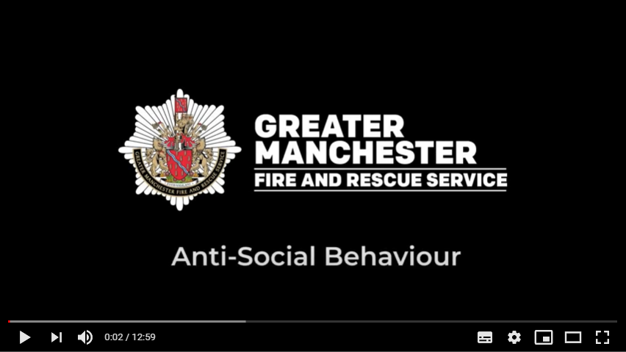 | Have the video up on the screen, paused and ready to play. Before you start the delivery make sure the audience can see the video.  Explain that you will be asking for audience involvement during the presentation.  Provide a brief introduction of yourself, role and the Safe4Summer campaign.  Introduction could be as follows – A new season is upon us - so whether you're on school holidays or generally out and about more with your friends and family, here is some safety information to help you keep safe. Today we are going to show you a video by Stephen (Steve) Wilcock a Watch Manager from Bury Fire Station with Greater Manchester Fire and Rescue Service which explains what anti-social behaviour (ASB) is and the dangers of playing with fire and/or making a hoax call.  Please watch and listen carefully as we will be asking you some questions later.  Press play on video. | Video
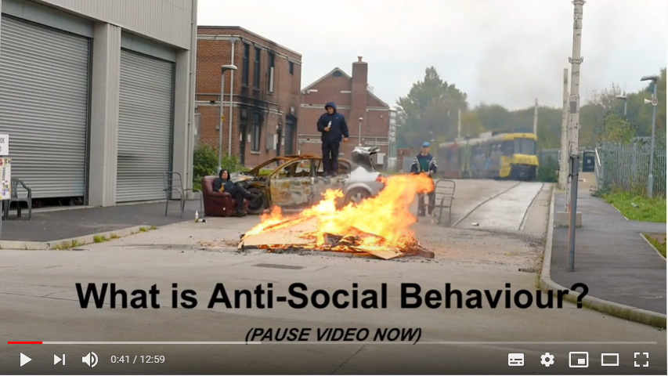 | PAUSE VIDEO…  Presenter to pause the video when directed at the time 0:40.  Q: Presenter to ask the audience if they have heard of the term anti-social behaviour (ASB) and what they think it means.  Provide praise for correct answers. | Video  Question and Answer
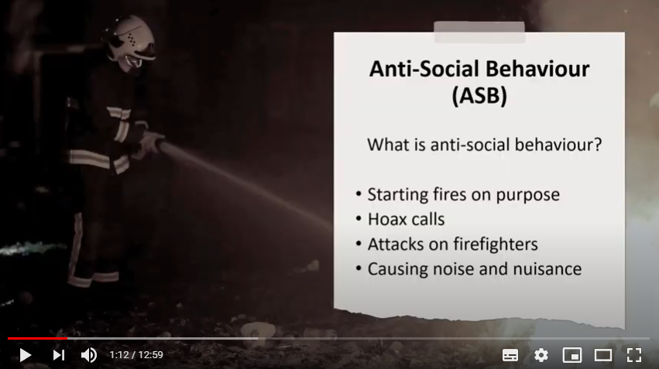 | Presenter to say: now let’s find out the answers from Steve.  Press play on the video.  *You might want to check audience understanding of what “on purpose” means as well as the word “nuisance”.* | Video
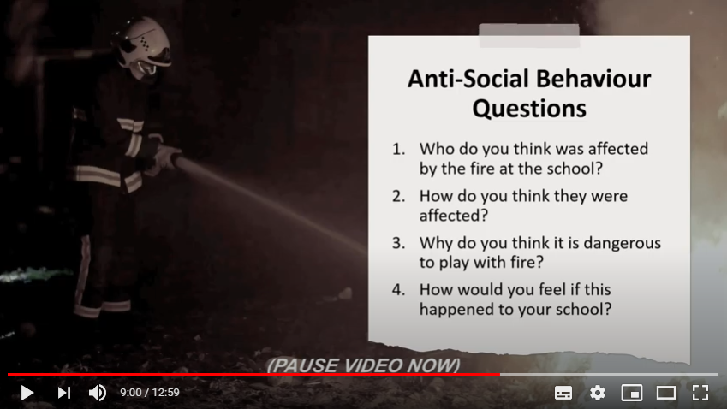 | PAUSE VIDEO…  Presenter to pause the video as directed at the time 9:00.  The purpose of the next 4 questions is to try and draw the key messages from the video out of the audience through engaging in a question and answer session.  The questions and key messages are detailed below:  Question 1 – Who do you think was affected by the fire at the school?  People affected:  - The school.  - The children who attended the school.  - The emergency services that attended the incident.  - The local community.  - The group of young people who set the fire.  **The above list is not exhaustive, please feel free add further examples of those affected during your discussions**  Question 2 – How do you think they were affected?  - School – The school had to close because of the damage caused by the fire. The damage was so severe that it cost an estimated £1 million to repair.  - School Children – The children were to unable to attend their school. The school was closed and temporary arrangements had to be made. All the school work / displays they had created were destroyed by the fire. The specialist equipment used for children with disabilities and special requirements was also damaged or destroyed.  - Emergency Services – Firefighter lives were put at risk tackling this fire (close to 50 Firefighters attended). This incident was preventable, the youths should not have been on the school and more importantly they should not have been playing with fire.  - Local Community – The local community was also affected, as there was a huge fire in their area and local people were unable to use the school for activities such as swimming.  - The group of young people who set the fire – The incident was caught on CCTV and evidence was handed to the police. The youths were arrested and all of them were charged with Arson and received sentences.  Question 3 – Why do you think it is dangerous to play with fire?  - You or someone could get seriously hurt – Playing with fire is very dangerous, you or someone else could get hurt e.g. slight burns / marks, to life changing injuries such as severe burns to hands or face.  - Potential loss of life – Playing with fire can have very serious consequences, someone could be killed. Imagine if there had been someone in the school at the time the group of young people had set that fire.  - Devastating and costly – It is very upsetting and distressing for all those affected by an incident of fire. Also the damage that a fire causes can be very expensive as whatever is damaged needs to be replaced or repaired. Relate it to the incident e.g. serious damage to property and/or possessions and the cost of repairs due to the damage.  - You can get in trouble with the police – Deliberately setting a fire could lead to a £5,000 fine or 6 month’s imprisonment. If you endanger life by deliberately setting a fire, you could be sentenced to life imprisonment.  Question 4 – How would you feel if this happened to your school?  Expand as required on any of the answers the children provide.  Praise correct answers throughout.  Remember – As you have seen on the video, playing with fire is very dangerous and can have serious consequences.  Please never play with fire – ask the whole audience to repeat the key message to you.  Press play on the video. | Video  Question and Answer
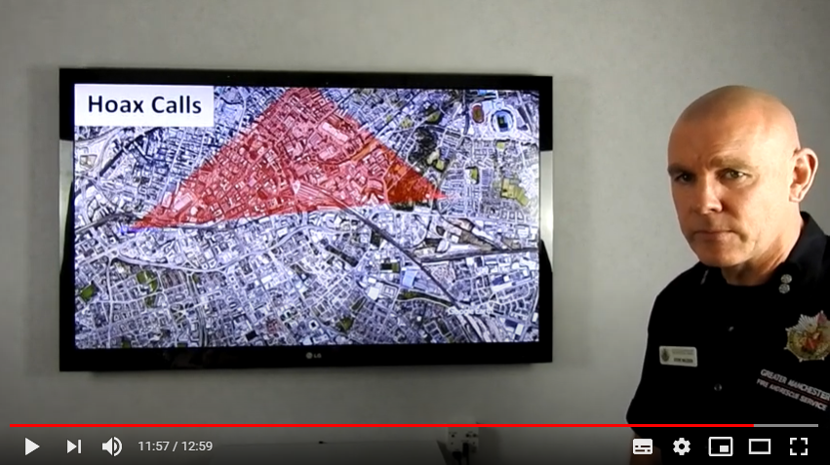 | PAUSE VIDEO…  Presenter to pause the video at the time of 11:57.  Q: Presenter to ask the audience what they think the dangers and consequences are for making a hoax call.  A: Go through or expand on any answers given.  - Firefighters can risk their lives attending every incident, including hoax calls.  - When our Firefighters are attending a hoax call, they cannot be at a real emergency.  - Responding to a hoax call puts other people’s lives at risk.  - All 999 hoax calls are traced and recorded.  - Hoax call information is given to the police for further action.  - A convicted hoax caller could face a fine of £5,000 and/or 6 months imprisonment.  - Never – make a hoax call.  Press play on the video. | Video  Question and Answer
 | Q: Once the video has finished, presenter to ask the audience what where the key messages from todays lesson on anti-social behaviour?  - Respect our firefighters.  - Never call/dial 999 unless it is an emergency.  - Never play with matches or lighters.  - Never make a hoax call.  - Never play with fire.  Ask the audience if they have any questions.  Presenter to give the final message – Please enjoy yourself with your friends and family but remember never put yourselves in situations that may be dangerous to yourself or others.  Think about the consequences of what could happen and how you and others may be affected.  Direct the audience to the Safe4Summer website (www.safe4summer.com) which has further advice and games on it.  Thank the audience for taking part in the session. | Video  Question and Answer

Please visit our Bury Safety Centre training site, which opens from the 28th June 2021 subject to Government guidelines. To find out more and to book a visit when we are back open please visit the website for here: https://safetycentre.manchesterfire.gov.uk/

