Fire Safety in the Home Primary School Lesson Plan for Delivery
Programme of Study for PSHE Education:
Keeping Safe Section
KS1 | H30. about how to keep safe at home (including around electrical appliances) and fire safety (e.g. not playing with matches and lighters).
KS2 | H39. about hazards (including fire risks) that may cause harm, injury or risk in the home and what they can do reduce risks and keep safe

Slide/Video information | Presenter notes – what to discuss | Source
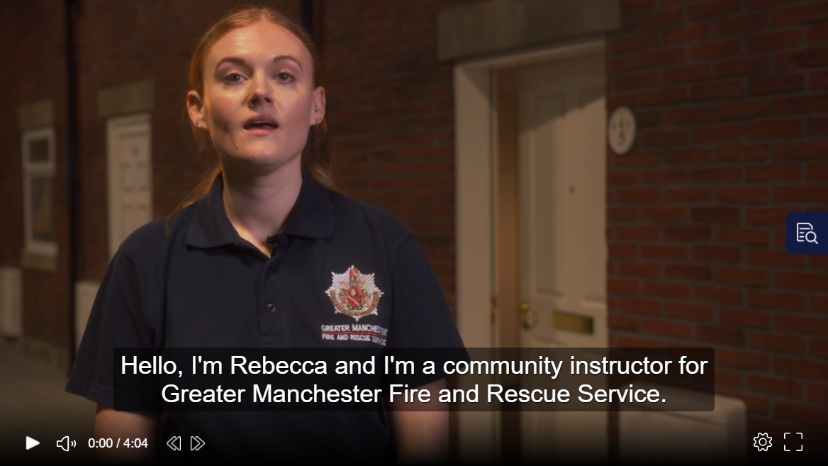 | Have the video up on the screen, paused and ready to play. Before you start the delivery make sure the audience can see the video.  Explain that you will be asking for audience involvement during the presentation.  Provide a brief introduction of yourself, role and the Fire Safety in the Home video.  Introduction could be as follows – Today we are going to show you a video by our Community/Prevention Education Instructors Rebecca, David and Colin who work for Greater Manchester Fire and Rescue Service. The video will teach you about the five main causes of fire in the home and how to keep you and your family safe from fire.  Please watch and listen carefully as we will be asking you some questions later.  Press play on video. | Video
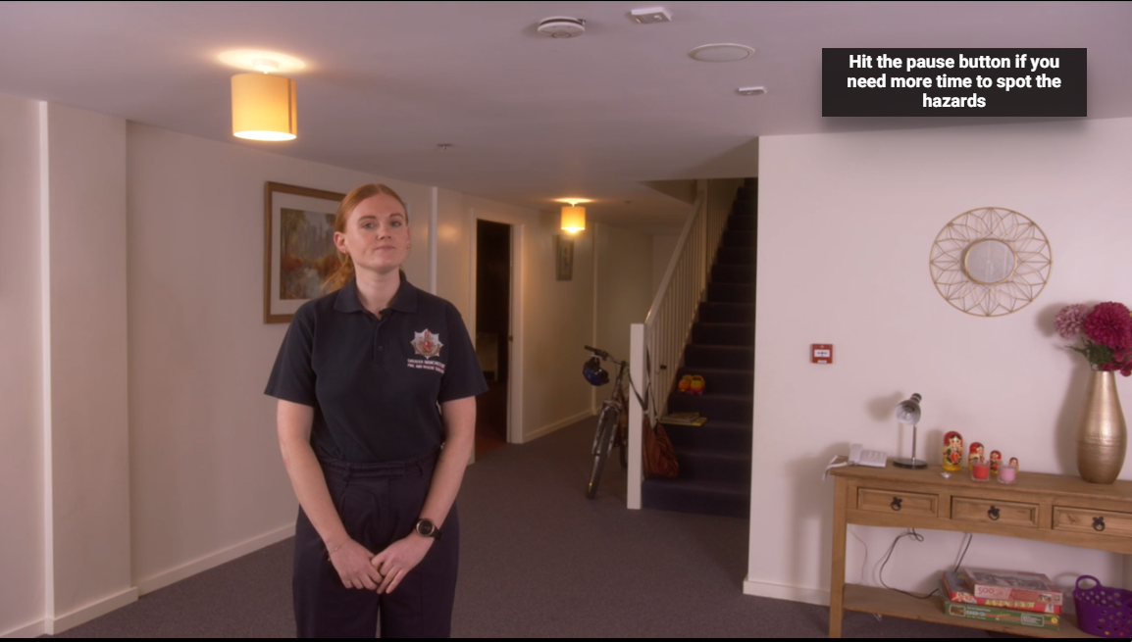  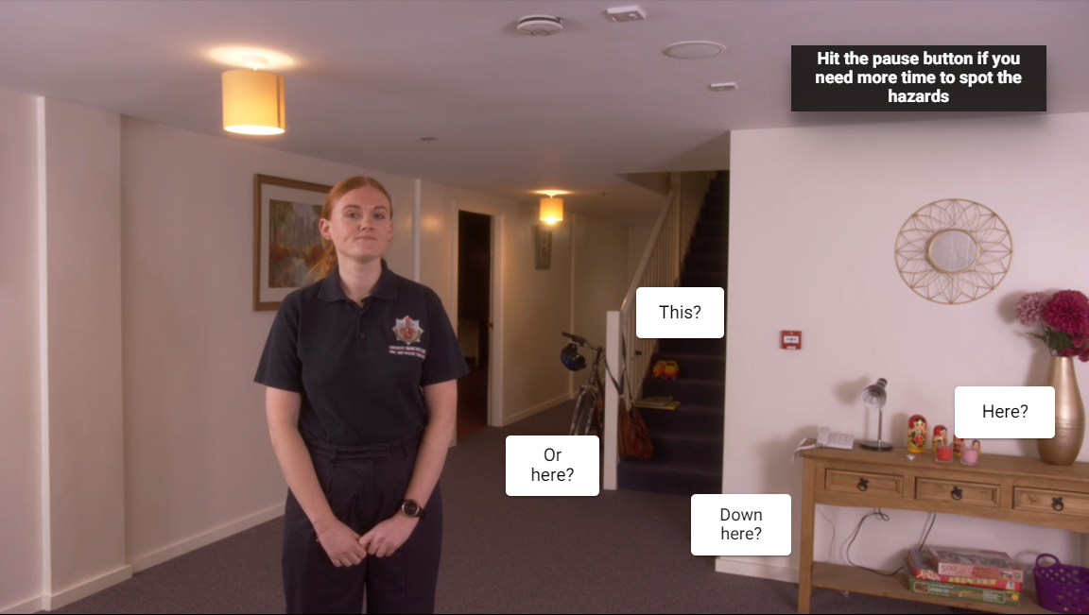 | PAUSE VIDEO…  Presenter to pause the video when directed at the time 0:38.  Q: Presenter to ask the audience if they can see anything that might be dangerous in the hall at Number 5 London Road.  Once discussed the presenter can press the play button and it will display some options. At this point the presenter may wish to pause the video again to click on the button tabs displayed. If the presenter clicks on either the “This?” “or here?” button options it will explain why having lots of items on or around your stairs is dangerous, as it can block your escape route out of the house if there was a fire or cause you to fall over and injure yourself on the way out of the house, which we don’t want either. We want everyone to leave the house quickly and safely if there was a fire.  If the presenter clicks on the “here” button option it will also explain why tealights are dangerous and the correct way to use candles in the home, for example making sure adults place candles in a correct and secure holder. Candles should also be placed away from any other materials which could set on fire, for example curtains. The “down here?” tab is a decoy tab and will direct the audience to try again.  Re-press play on the video for the next section. | Video  Question and Answer
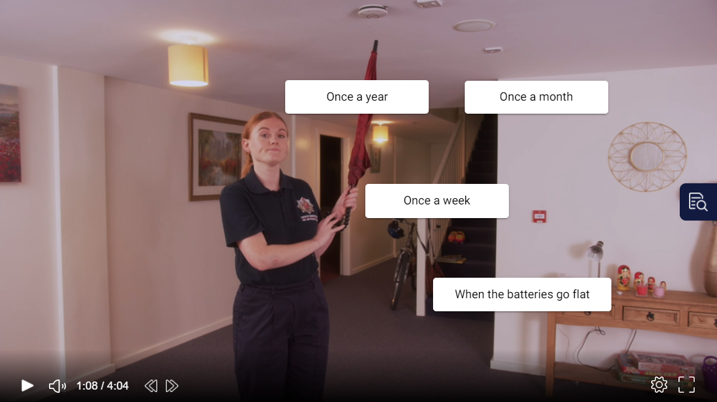 | PAUSE VIDEO…  Presenter to pause the video on the time of 1:08.  Presenter to check that the audience firstly understands what a smoke alarm is. Explain that smoke alarms are very important and every home should have them. They detect (or sense) smoke and alert you if there is a fire in your home so you can escape safely.  Presenter to ask the audience if they have smoke alarms at home or not. If they don’t or are unsure, they should be directed to ask the adult of the house when they get home. *Smoke alarms can be bought at most supermarkets*.  Q: presenter to ask the audience how often do they think they should test their smoke alarm? They can choose from the options provided on the screen.  Once an agreed option has be decided from the audience the presenter can click on the chosen tab, which will tell them if they are correct or not. The correct answer is “Once a week”.  You can test by pressing the button, if they are working, they will make a loud bleeping noise as shown in the video. If you can’t reach, ask an adult to do it or you can use other household items such as an umbrella or a brush to reach and press the button, please never stand or climb on furniture, in case you fall and injure yourself.  Press play on the video. | Video  Question and Answer
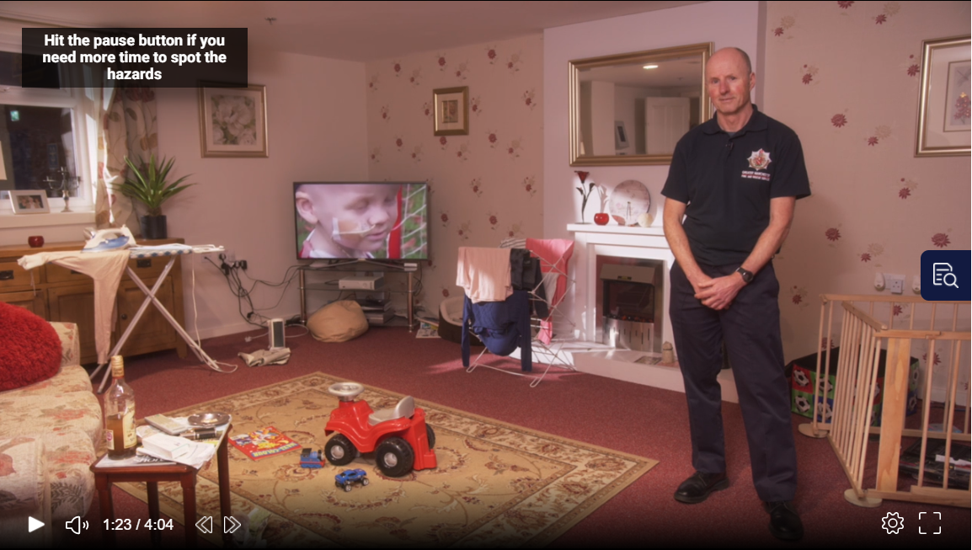  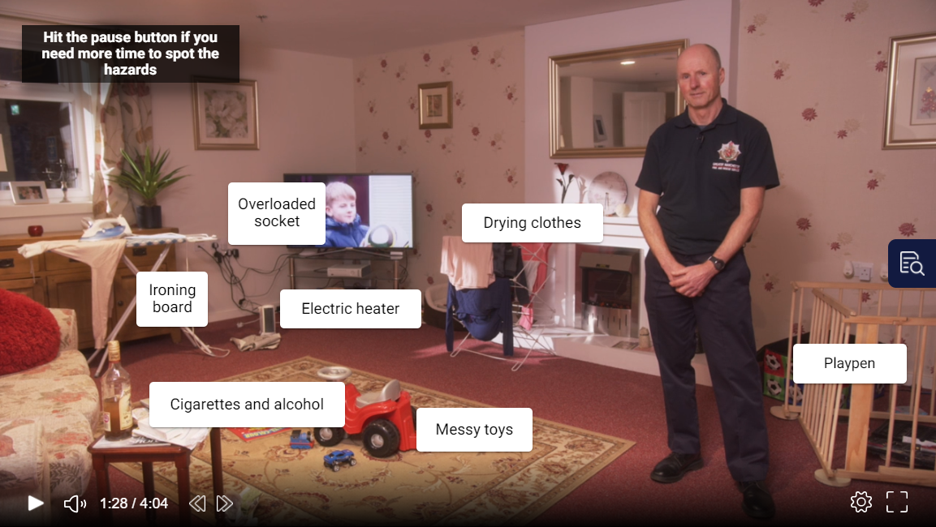 | PAUSE VIDEO…  Pause the video when directed at the time of 1:23.  Q: Presenter to ask the audience what hazards they can see in the room and why they think they are a hazard.  Once the audience has given some ideas press play on the video for 5 seconds until it reaches the time of 1:28 and then pause the video again. Presenter should click on each of the tab button options provided on screen which will go through in more detail which are hazards and why, with some safety advice. The presenter will need to re-pause the video in between clicking on each tab button otherwise the video will move on.  Re-press play on the video for the next section. | Video  Question and Answer
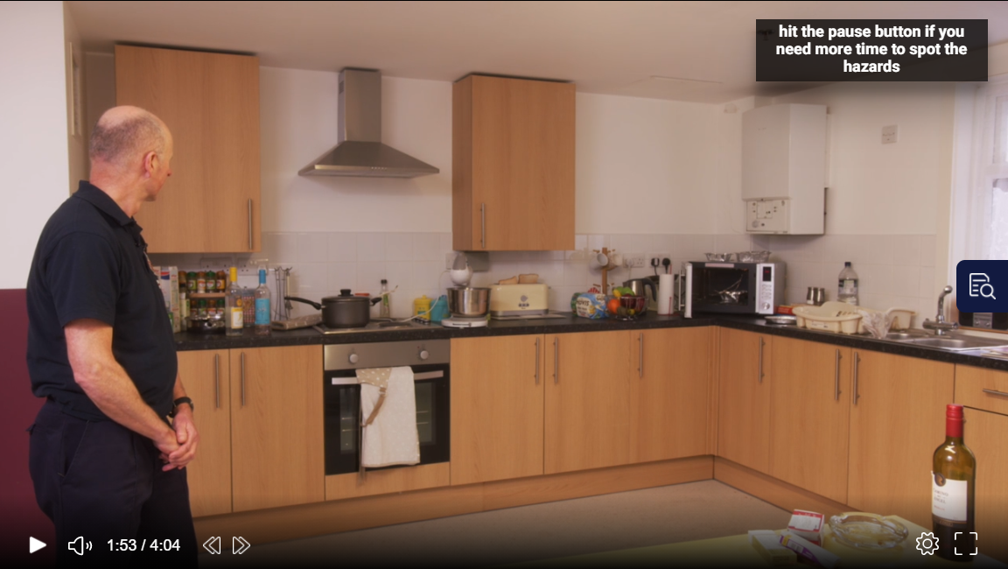  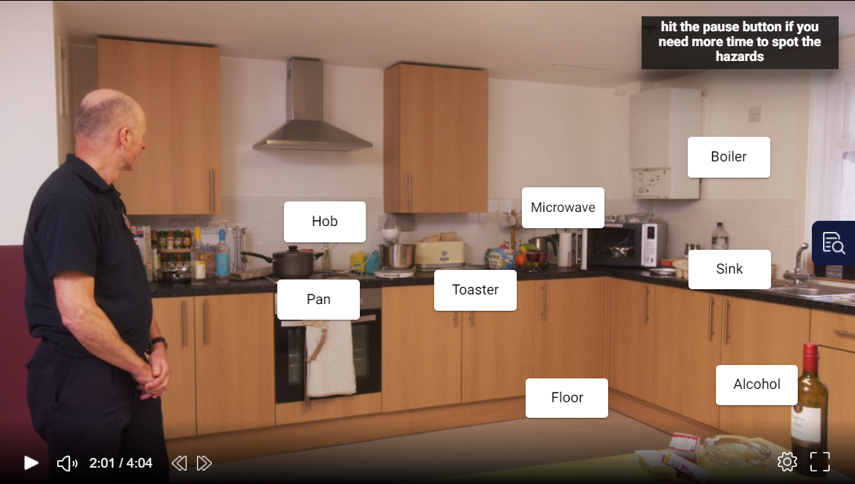 | PAUSE VIDEO…  Pause the video when directed at the time of 1:53.  Q: Presenter to ask the audience what hazards they can see in the room and why they think they are a hazard.  Once the audience has given some ideas press play on the video until it reaches the time of 2:01 and then pause the video again. Presenter should click on each of the tab button options provided on screen which will go through in more detail which are hazards and why, with some safety advice. The presenter will need to re-pause the video in between clicking on each tab button otherwise the video will move on.  Re-press play on the video for the next section. | Video  Question and Answer
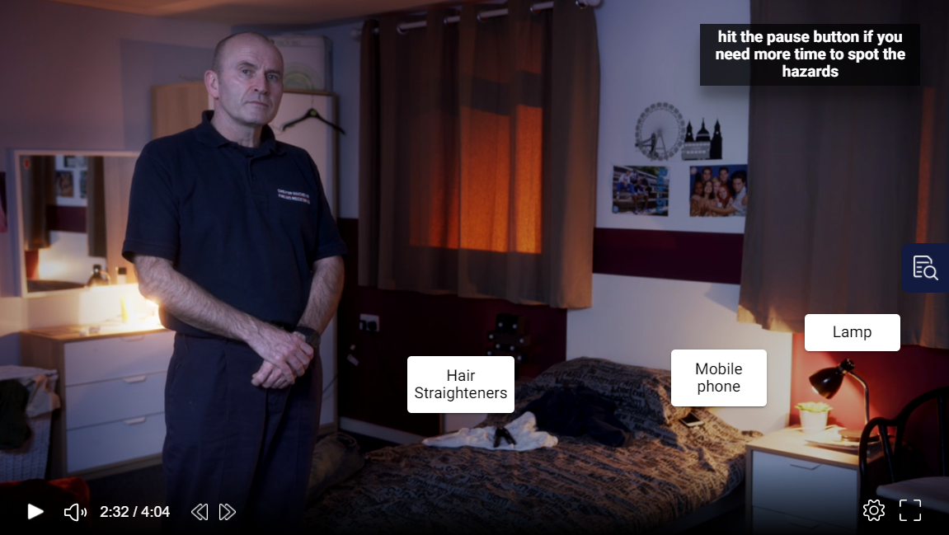 | PAUSE VIDEO…  Pause the video when directed at the time of 2:26.  Q: Presenter to ask the audience what hazards they can see in the room and why they think they are a hazard.  Once the audience has given some ideas press play on the video until it reaches the time of 2:32 and then pause the video again. Presenter should click on each of the tab button options provided on screen which will go through in more detail which are hazards and why, with some safety advice. The presenter will need to re-pause the video in between clicking on each tab button otherwise the video will move on.  Re-press play on the video for the next and final section. | Video  Question and Answer
 | Presenter to recap/check knowledge and understanding from what the audience have learnt from today’s session:  - What the 5 main causes of fire in the home are?  - What is a smoke alarm, how do you test it and how often should you test it?  - What a hazard is and some examples of a hazard?  - Any advice the community/prevention education instructors gave you?  - And finally what did a bedtime routine involve?  Presenter to ask the audience to pass on these key messages they have learnt from today’s session to their family and friends.  Direct the audience to the Safe4Summer website (www.safe4summer.com) which has further advice and games on it.  Ask the audience if they have any questions.  Thank the audience for taking part in the session. | Video  Question and Answer  Any questions

Please visit our Bury Safety Centre training site, which opens from the 28th June 2021 subject to Government guidelines. To find out more and to book a visit when we are back open please visit the website for here: https://safetycentre.manchesterfire.gov.uk/

