Safe4Summer: Anti-Social Behaviour Secondary School Lesson Plan for Delivery

Programme of Study for PSHE Education:
Managing risk and personal safety and Social influences section.
KS3 | Social influences: R45. about the factors that contribute to young people joining gangs; the social, legal and physical consequences of gang behaviours.  Social influences: R47. motivations, misconceptions and consequences of carrying weapons and strategies for managing pressure to carry a weapon.
KS4 | Managing risk and personal safety: H23. strategies for identifying risky and emergency situations, including online; ways to manage these and get appropriate help, including where there may be legal consequences (e.g. drugs and alcohol, violent crime and gangs).  Social influences: R35. to evaluate ways in which their behaviours may influence their peers, positively and negatively, including online, and in situations involving weapons or gangs.

Slide/Video information | Presenter notes – what to discuss | Source
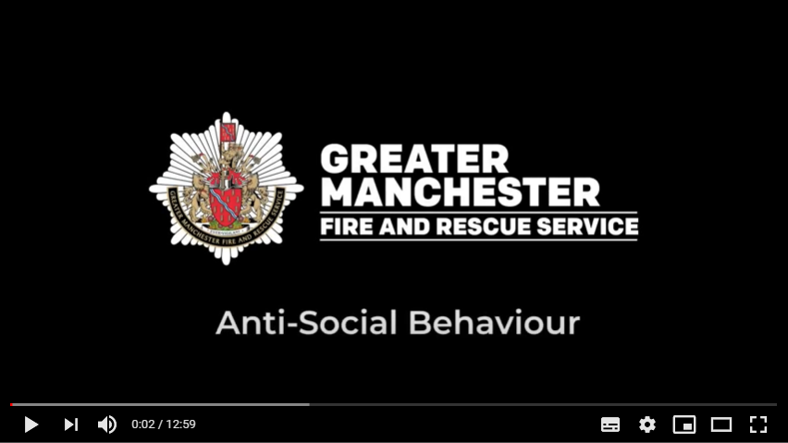 | Have the video up on the screen, paused and ready to play. Before you start the delivery make sure the audience can see the video.  Explain that you will be asking for audience involvement during the presentation.  Provide a brief introduction of yourself, role and the Safe4Summer campaign.  Introduction could be as follows – A new season is upon us - so whether you're on school holidays or generally out and about more with your friends and family, here is some safety information to help you keep safe. Today we are going to show you a video by Luke Rees a Prevention Education Instructor with Greater Manchester Fire and Rescue Service which explains what anti-social behaviour (ASB) is, the dangers and consequences of deliberately setting fires and/or making a hoax call, along with covering attacks on firefighters.  Please watch and listen carefully as we will be asking you some questions later.  Press play on video. | Video
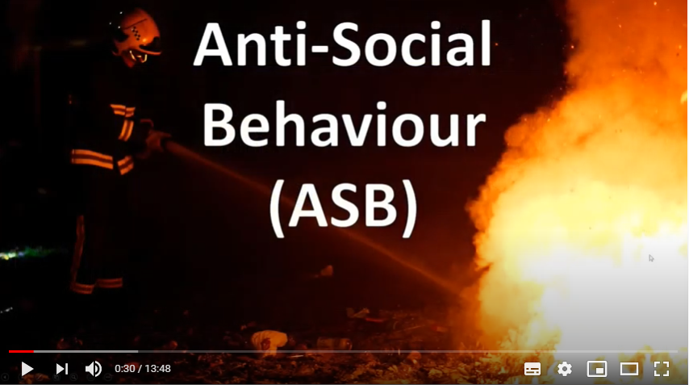 | PAUSE VIDEO…  Presenter to pause the video at the time 0:30.  Q: Presenter to ask the audience if they know what the term anti-social behaviour (ASB) means and can they give some examples of ASB?  Provide praise for correct answers.  “Now say let’s find out from Luke”.  Press play on the video. | Video  Question and Answer
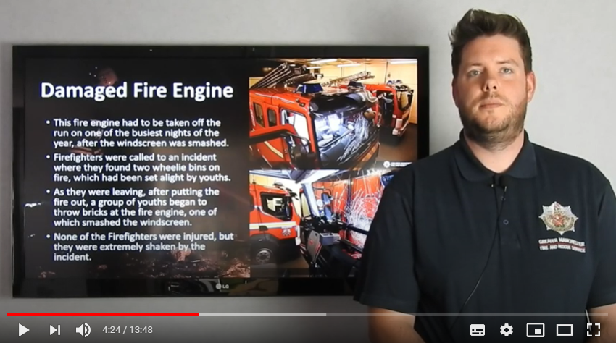 | PAUSE VIDEO…  Presenter to pause the video at the time of 4:24.  Presenter to repeat the two questions Luke asked.  Q1: Do you believe it is right that firefighters have to put up with ASB?  Q2: How might this behaviour impact on others who may need a fire engine that night?  The audience should discuss these questions.  Sometimes it is a good idea to ask the audience how many fire stations and how many fire engines they think Greater Manchester Fire and Rescue Service (GMFRS) have to cover the whole of Greater Manchester.  GMFRS serve a population of 2.8 million people across 10 boroughs which include, Bolton, Bury, Manchester, Oldham, Rochdale, Salford, Stockport, Tameside, Trafford and Wigan, covering an area of approximately 496 square miles. To cover this large area the service has 41 stations and a total of 50 engines as some stations have more than one engine or appliance.  No one should have to experience ASB. Firefighters already risk their lives attending incidents but ASB should never be a worry. If firefighters are injured during an ASB attack it leaves the Watch for that engine short of staff members, they may need medical attention and not be able to work, which all has long term effects on the firefighter/s. If the fire engine/appliance is damaged this means that the engine is no longer available for real emergencies, potentially putting other lives at risk.  Press play on the video.
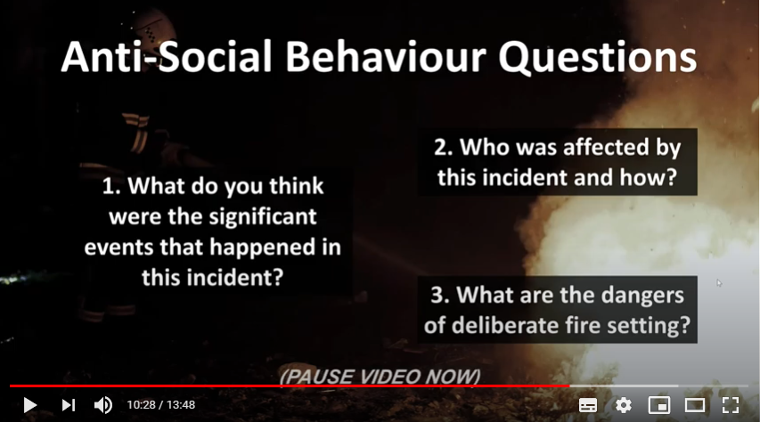 | PAUSE VIDEO…  Presenter to pause the video at the directed time of 10:28.  The purpose of the next 3 questions is to try and draw the key messages from the video out of the audience through engaging in a question and answer session.  Question 1 – What do you think were the significant events that happened in this incident?  - The group of youths trespassed on school property – The youths congregated on school property. They should not have been on there in the first place.  - They were in possession of smoking materials e.g. lighters / matches – They started the fire using lighters / matches, therefore were in possession of smoking materials. They should not have been in possession of smoking materials, they were aged 14 and 15 years old.  - They deliberately set a fire in the school – The group of young people set the fire using a takeaway tray. They left the school and the fire spread onto the wall and roof space. One member of the group said he was “too lazy” to extinguish the initial flame. This could have prevented this incident.  Question 2 – Who was affected by this incident and how?  Discuss the ‘ripple effect’ with the audience.  People affected and how:  - School – The school had to close due to the severity of the damage. There was a huge cost implication due to the damage caused to the property and specialist equipment in the building (estimated £1 million).  - School Children – The children were unable to attend the school due to its closure, therefore temporary arrangements had to be made. All the work they had created / developed within school was destroyed. Specialist equipment used for their disabilities and requirements was also damaged or destroyed.  - Emergency Services – Firefighter lives were put at risk tackling such a serious fire. The roof was unstable and visibility was poor due to the amount of smoke causing an increased risk to Firefighter safety. Ultimately, the fire service attended an incident that should never have happened. A lot of resources were used (close to 50 Firefighters) on an incident which was preventable.  - Local Community – The local community was also affected, as there was a huge fire in their area and local people were unable to use the school for activities such as swimming.  - The group of young people who committed the offence – The incident was captured on CCTV and evidence was handed to the police for investigation. Each member of the group was arrested and all of them were charged with Arson and received sentences.  - Two of the youths received a 12-month intensive referral order and the other was given an 18-month rehabilitation order and placed on a curfew for three months.  Question 3 – What are the dangers and consequences of deliberate fire setting?  - You or someone could get seriously hurt – You or someone else could get injured e.g. superficial injuries such as slight burns or marks, to life changing injuries for example severe burn to hands / face etc.  - Potential loss of life – Someone could be killed. Imagine if there had been someone in the school at the time the group of young people had set that fire.  - Devastating and costly – Relate it to the incident e.g. serious damage to property and/or possessions. The cost of repairs due to the damage.  Press play on the video. | Video  Question and Answer
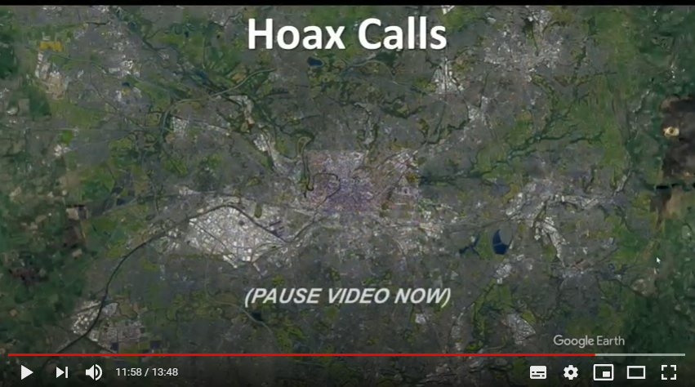 | PAUSE VIDEO…  Presenter to pause the video at the directed time of 11:58.  Q: Presenter to ask the audience what they think the dangers and consequences are for making a hoax call.  A: Go through or expand on any answers given.  - Firefighters can risk their lives attending every incident, including hoax calls.  - When our Firefighters are attending a hoax call, they cannot be at a real emergency.  - Responding to a hoax call puts other people’s lives at risk.  - All 999 hoax calls are traced and recorded.  - Hoax call information is given to the police for further action.  - A convicted hoax caller could face a fine of £5,000 and/or 6 months imprisonment.  Key message: Never – make a hoax call.  Press play on the video. | Video  Question and Answer
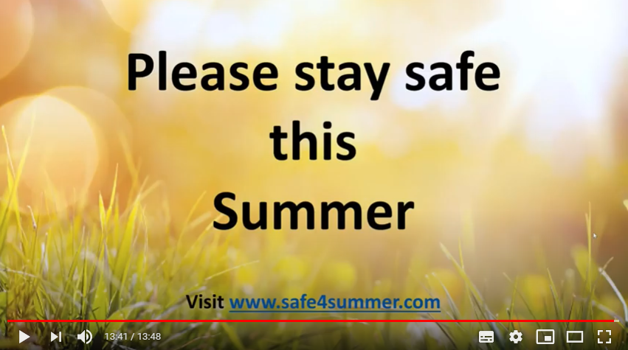 | Presenter to pause the video at the end so that you can see the safe4summer weblink.  Q: Once the video has finished, presenter to ask the audience what where the key messages from todays lesson on anti-social behaviour?  - Respect our firefighters.  - Never dial 999 unless it is a real emergency.  - Never make a hoax call.  - Never deliberately set a fire.  - Never engaged in Anti-Social Behaviour.  Ask the audience if they have any questions.  Presenter to give the final message – Please enjoy yourself with your friends and family but remember never put yourselves in situations that may be dangerous to yourself or others.  Think about the consequences of what could happen and how you and others may be affected.  Direct the audience to the Safe4Summer website (www.safe4summer.com) which has further advice and games on it.  Thank the audience for taking part in the session. | Video  Question and Answer

Please visit our Bury Safety Centre training site, which opens from the 28th June 2021 subject to Government guidelines. To find out more and to book a visit when we are back open please visit the website for here: https://safetycentre.manchesterfire.gov.uk/

