Safe4Summer: Grassfires Secondary School Lesson Plan for Delivery
Programme of Study for PSHE Education: Managing risk and personal safety
KS3 | H30. how to identify risk and manage personal safety in increasingly independent situations, including online.  H31. ways of assessing and reducing risk in relation to health, wellbeing and personal safety.
KS4 | H22. ways to identify risk and manage personal safety in new social settings, workplaces, and environments, including online.  H23. strategies for identifying risky and emergency situations, including online; ways to manage these and get appropriate help, including where there may be legal consequences (e.g. drugs and alcohol, violent crime and gangs).

Slide/Video Information | Trainer notes – what to discuss | Source/Activity
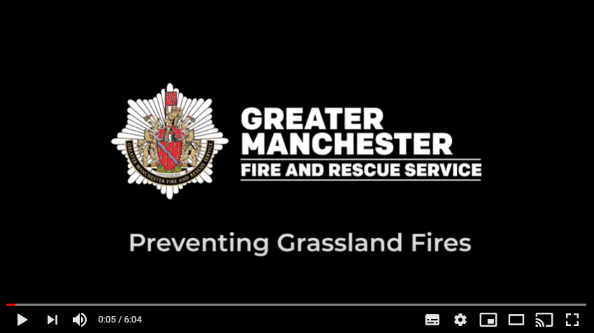 | Have the video up on the screen, paused and ready to play. Before you start the delivery make sure the audience can see the video. Provide a brief introduction of yourself, role and the Safe4Summer campaign.  Introduction could be as follows – Today we are going to show you a video with some safety tips by Rebecca Sutherland a Prevention Education Instructor from Greater Manchester Fire and Rescue Service to help you keep safe in and around grasslands.  Rebecca will talk about:  - The main causes of grassfire and moorland fires  - What you can do to prevent a grassfire  - The damage caused by grassfires  Please watch and listen carefully as we will be asking you some questions later.  Press play on video. | Video
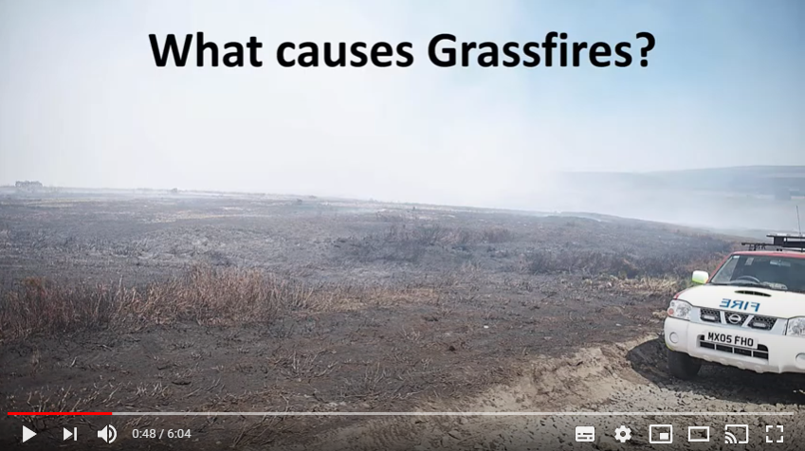 | PAUSE VIDEO…  Presenter is to pause the video at the time 0:48  Q: Presenter to ask the audience what they know about the moorland fires and what they think are the most common causes of grassland fires?  Provide praise for correct answers.  Press play on the video and Rebecca will go through the answers. | Video  Question and Answer
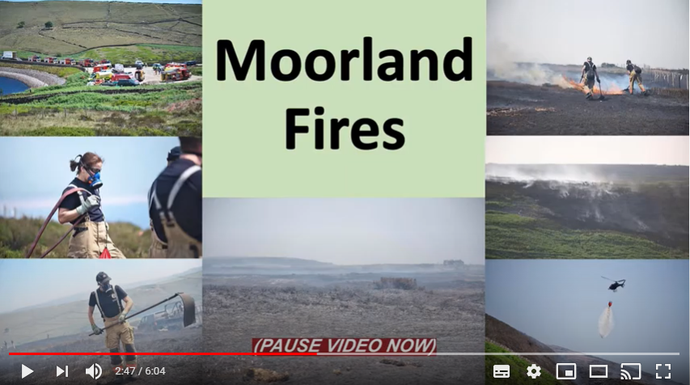 | PAUSE VIDEO…  Presenter is to pause the video at the direct time of 2:47.  Presenter to repeat the question to the audience: Can you think of any other grassfires and how they started?  Rebecca mentioned the Saddleworth Moor and Winter Hill moorland fires here is some further information.  Saddleworth Moor - 2018  Fire first broke out on Saddleworth Moor, between Sheffield and Manchester, on 24th June 2018. The fire was extinguished later that same day but the next day, pockets of the fire re-ignited, probably from the burning of peat which had dried out deep; this began to burn out of control from 26th June, and a major incident was declared that day. By 27th June, the moorland fire had grown to cover over 2,000 acres. Rapidly changing wind speed and direction helped the fire to spread quickly across the dry moorland. 29 fire engines and more than 100 firefighters were at the scene of the fire. The fire was believed to have started due to hot and dry weather conditions, but the police did investigate it as arson as people were seen lighting a bonfire on the moors near Stalybridge on 24th June.  Winter Hill – 2018  A large fire broke out on Winter Hill, north of Bolton on Thursday 28 June 2018. Initially, five fire engines from Greater Manchester and seven from the Lancashire Fire and Rescue Service were sent to tackle the blaze with specialist fire-fighting equipment. They were supported by firefighting teams from United Utilities and volunteers and vehicles from Bolton Mountain Rescue Team, and later other local volunteer teams including Lancaster Area Search and Rescue. By 2nd July 2018, the fire covered over six square miles with up to one hundred firefighters and more than 20 fire engines tackling the blaze. The fire was brought under control on 16th July, in total it had spread over 7 square miles. On 29th June 2018 a 22-year-old man was arrested for arson with intent to endanger life, on suspicion of starting the initial Winter Hill fire.  Some other examples you may have seen or heard about on the news.  Bushfires in Australia – 2019-2020  From September 2019 until March 2020, when the final fire was extinguished, Australia had one of the worst bush fire seasons in its recorded history. 2019 had been the hottest record year for Australia, with the bushfire season starting in June 2019. This caused massive damage throughout the country, with fires in each state and territory. The east coast experienced widespread destruction, some of it permanent damage, such as the burning of remnant rainforest. The fires burnt an estimated 18.6 million hectares (46 million acres. It is thought that the bushfires started due to a combination of the intense heat and strong winds during Australia's summer months which made the fires spread rapidly across parts of the country.  Wildfires in California – 2020  By the end of the year Southern California experienced a total of 9,917 fires, which burned an area of about 4,397,809 acres resulting in 16 fatalities, seriously injuring firefighters and forced over 100,000 people to evacuate in what was referred to as the worst wildfire season the state had seen on record. There were around 3,400 firefighters plus personnel fighting the wildfires in the United States. The wildfires were ignited in California in August after an “unprecedented outburst of dry lightning”. This year also recorded at least ten lightning complex fires. One reason could be that climate change is leading to more lightning storms and partly due to poor forest management.  These are just some examples, and you may have discussed others.  Press play on the video. | Video  Question and Answer
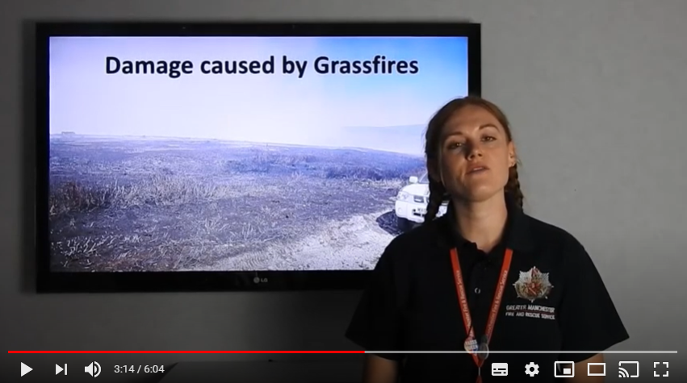 | PAUSE VIDEO…  Presenter to pause the video at the time of 3:14.  Presenter to repeat the question:  Q: What impact or damage do you think grassfires have?  Praise correct answers.  Press play on the video and Rebecca will go through the answers. | Video  Question and Answer
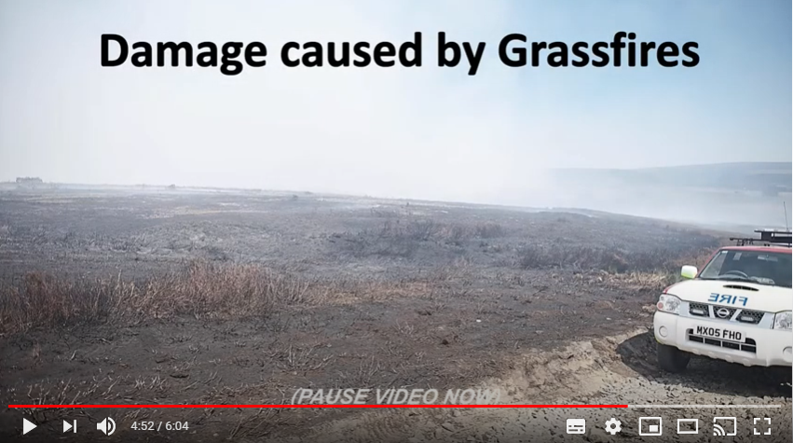 | PAUSE VIDEO…  Presenter to pause the video at the time of 4:52.  Presenter to repeat the question:  Q: Can you think of any other damage that can be caused by grassfires.  Saddleworth Moor fire: The fire rapidly started approaching populated areas, around 150 people had to be evacuated from 50 homes close to the advancing fire. The smoke drifted which caused a drop in air quality. One GP at a Manchester surgery told the BBC News that he had treated numerous people suffering from respiratory illnesses relating to the fire, including nosebleeds, coughs and eye problems. The burning caused particle pollution to reach as far away as Wigan, Warrington and St Helens - 37 miles away. This pollution reached an eight out of ten on the air quality index.  Winter Hill - A United Utilities helicopter had to drop tons of water from the nearby Rivington Reservoirs onto the fire to help get it under control, which is a waste of essential resources, as reservoirs are used for our drinking water. There was pollution damage similar to that of the Saddleworth Moor fires. The fire also caused a number of roads and footpaths in the area to be closed due to public safety, with firefighters later setting up a 'four-mile no-go zone' around the affected area, causing distributions to the local community.  Bushfires in Australia – The cost of dealing with the bushfires is expected to exceed the A$4.4 billion. Economists estimated that the Australian bushfires may cost over A$103 billion in property damage and economic losses, making the bushfires Australia's costliest natural disaster to date. The fires destroyed over 5,900 buildings (including 2,779 homes) and killed at least 34 people. The bushfires kill animals and also destroyed local habitats, it is estimated that in the first three months of the 2019–2020 bushfires, over 800 million animals died with many others dying later due to the depletion of food and shelter resources. Reptiles were affected by the fires and some endangered species were believed to be driven to extinction.  Wildfires in California - The fires destroyed over 10,000 structures and cost over $12.079 billion (2020 USD) in damages, including over $10 billion in property damage and there where 16 fatalities.  Press play on the video. | Video  Question and Answer
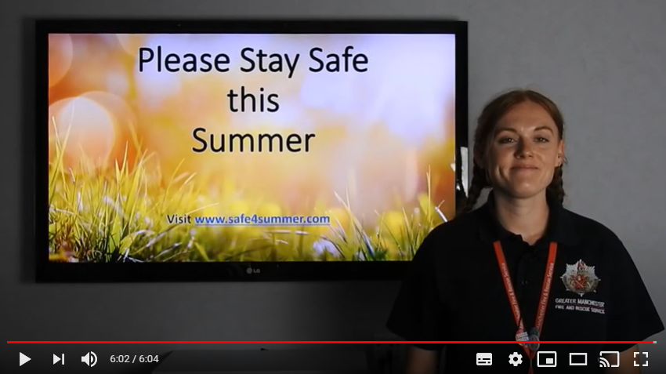 | PAUSE VIDEO…  Pause the video at the time 6:02 when you see the Please Stay Safe screen appear and Rebecca says thank you for watching.  Q: Presenter to ask the audience if they can remember how to prevent grassland fires Rebecca gave in the video?  Praise correct answers.  Answers:  Cigarettes should be extinguished properly, take litter home with you, never light a barbeque on the grass, never light camp fires in open grassland, never start a deliberate fire.  Presenter to empathise the point of how fast these fires can spread and the damage it causes.  Presenter to encourage the audience to take these messages home to their families too. | Video  Question and Answer
 | Final message – Please enjoy yourself with your friends and family but remember never put yourselves in vulnerable situation and stay safe.  Think about the consequences of what could happen and how you and others may be affected.  Ask if there are any final questions.  Direct them to the Safe4Summer website (www.safe4summer.com) and where they can find the games and further advice.  Thank the audience for taking part in the session. | Video  Website

Presenter should inform teachers of our Bury Safety Centre training site, which opens from the 28th June 2021 subject to Government guidelines if they are not already aware. To find out more and to book a visit when we are back open please share the website for Bury Safety Centre: https://safetycentre.manchesterfire.gov.uk/

