Safe4Summer: Water Safety Secondary School Lesson Plan for Delivery

Programme of Study for PSHE Education: Managing risk and personal safety
KS3 | H30. how to identify risk and manage personal safety in increasingly independent situations, including online.  H31. ways of assessing and reducing risk in relation to health, wellbeing and personal safety.
KS4 | H22. ways to identify risk and manage personal safety in new social settings, workplaces, and environments, including online.  H23. strategies for identifying risky and emergency situations, including online; ways to manage these and get appropriate help, including where there may be legal consequences (e.g. drugs and alcohol, violent crime and gangs).

Slide/Video Information | Presenter notes – what to discuss | Source
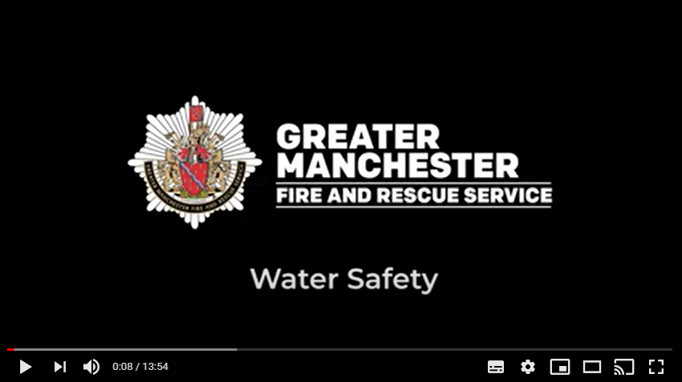 | Have the video up on the screen, paused and ready to play. Before you start the delivery make sure the audience can see the video. Provide a brief introduction of yourself, role and the Safe4Summer campaign.  Introduction could be as follows – Today we are going to show you a video with some safety tips by Dewan Gazi a Firefighter at Rochdale Fire Station for Greater Manchester Fire and Rescue Service to help you keep safe in and around water.  Dewan Gazi will talk about:  - The dangers and consequences of swimming in open water  - What to do if you see someone in difficulty  - And how to stay safe around open water  Please watch and listen carefully as we will be asking you some questions later.  Press play on video. | Video
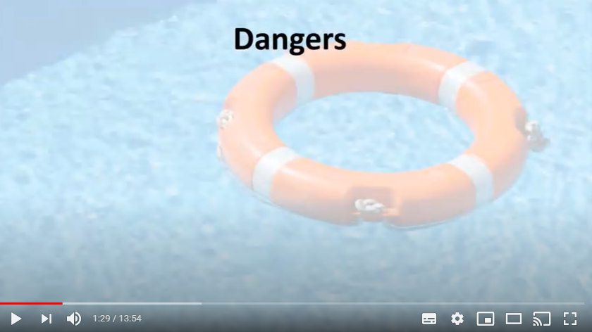 | PAUSE VIDEO…  Presenter is to pause the video at the time 1:29.  Q: Presenter to ask the audience if they can think of why swimming in open water can be dangerous?  Provide praise for correct answers.  Presenter to say: now let’s find out the answers from Dewan.  Press play on the video.  PAUSE VIDEO…  Presenter is to pause the video at the time 2:03  Q: Presenter to ask the audience, what they think cold water shock is and what would happen to your body in cold water?  Presenter to explain in more detail the body’s reaction to cold water:  One of the most dangerous issues is the cold. The coldness of the water can change body functionality. In very cold water our blood flow changes in an attempt to keep our core organs warm, and that can cause cramp in our muscles. People can get cramp and go under the water. Then panic can cause the inhalation of water meaning that lungs become flooded. At that point even strong swimmers are in severe danger of drowning, and it can happen extremely quickly.  The coldness of the water (even on a hot day) will affect your ability to swim. Think about how your fingers feel if you put them into a bowl of cold water. Imagine your whole body feeling like that. Your muscles will not be able to keep you afloat like they do in the warm swimming pool.  Presenter to say: now let’s go back to Dewan for further dangers of swimming in open water.  Press play on the video. | Video  Question and Answer
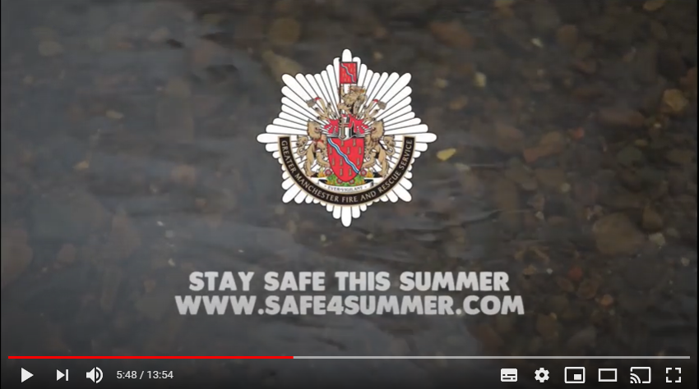 | PAUSE VIDEO…  Pause the video at the time 5:58, when you see the GMFRS logo appear.  Q: Presenter to ask what do you think are the key things that occurred in the incident the Firefighter discussed?  - She got into difficulty and could not get out of the water – The girl attempted to rescue her dog but was unable to due to the conditions of the water. She then got into difficulty and could not get back to shore leaving her in a very serious and life threatening situation. Furthermore, the dog came to no harm as it got out of the water safely by itself.  - Several emergency services attended the incident – Numerous emergency services attended this one incident (fire, police and ambulance). All these services attended an incident that could have been prevented if the girl had refrained from entering the water.  - She was able to get out of the water, but was extremely lucky – The girl got out of the water however she was very lucky. The current was strong and she could have been washed further down the river.  Q: Presenter to ask the audience if they can remember the advice or key messages Firefighter Simon Dowling gave in the video?  Praise correct answers.  Answers: Stay calm, ring 999, say where you are, give landmarks, what has happened, get something to hold onto or something you can throw to the person in trouble, never go in.  Presenter to empathise the last point that even the strongest swimmers struggle in cold water and Firefighter Dewan is now going to tell you about a time this sadly happened.  Press play on video. | Video  Question and Answer
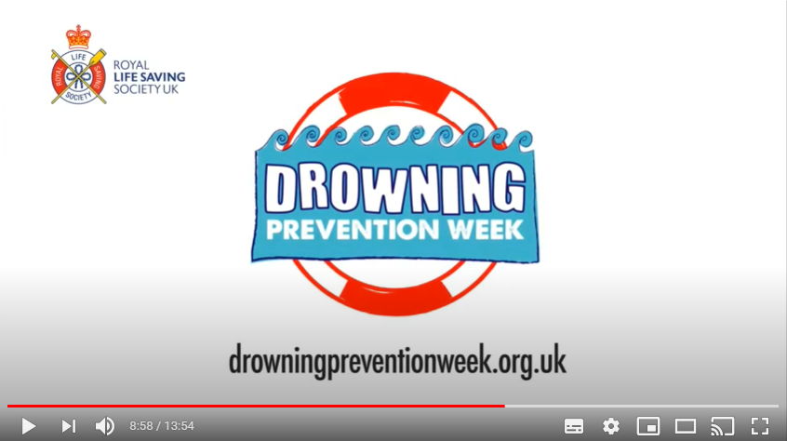 | PAUSE VIDEO…  Presenter to pause the video at the time 8:54.  Q: Presenter to ask the audience – Why did he go into the water?  - Tom dared him to  - The water looked shallow at least in places – you could see the bottom  - He couldn’t resist a challenge  - It wasn’t far to the other bank  Ask the audience – why did he find himself in difficulty?  - The water was deeper than it looked  - He swallowed water when his head went under  - It was colder than he expected  - The current dragged him down  - The weeds got wrapped around his feet  Ask the audience – why did he say his fingers felt funny?  The coldness of the water meant his body couldn’t function properly. In very cold water our blood flow changes in an attempt to keep our core organs warm, and that can cause cramp in our muscles and a tingly feeling in our fingers. At that point, even strong swimmers are in severe danger of drowning, and it can happen very quickly.  Key message is Never go into open water.  Press play on video. | Video  Question and Answer
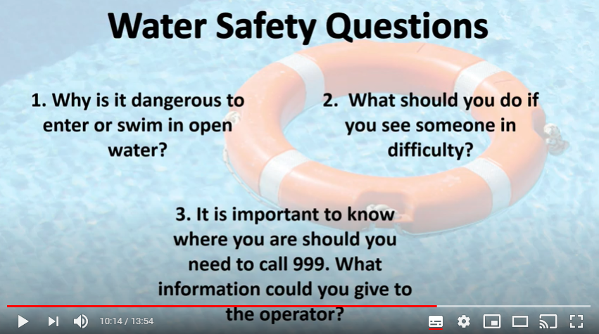 | PAUSE VIDEO…  Presenter to pause the video at the time 10:14.  Allow the audience some time to discuss and answer the questions on screen.  Dewan will then go through the answers on the video.  Press play on video. | Video
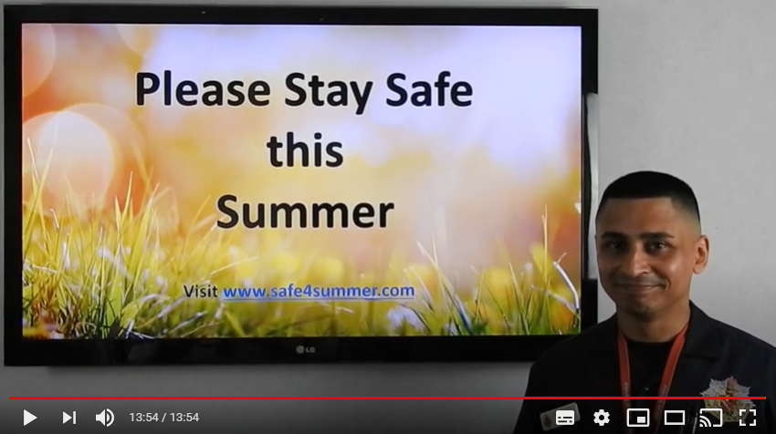 | PAUSE VIDEO…  Pause the video to finish at the time 13.54, so that the audience can see the safe4summer website link.  Final message – Please enjoy yourself with your friends and family but remember never put yourselves in situations that may be dangerous to yourself or others.  Think about the consequences of what could happen and how you and others may be affected.  The local swimming pool is a safe environment where you can have fun with your family and friends.  NEVER go in open water, as we want you all to stay safe this summer and to return home safely to your loved ones  Ask if there are any final questions.  Direct the audience to the Safe4Summer website (www.safe4summer.com) and where they can find the games and further advice.  Thank the audience for taking part in the session. | Video  Website

Please visit our Bury Safety Centre training site, which opens from the 28th June 2021 subject to Government guidelines. To find out more and to book a visit when we are back open please visit the website for here: https://safetycentre.manchesterfire.gov.uk/

